**Case Study: Car booking Service**

* The current implementation of Car booking Service is as follows 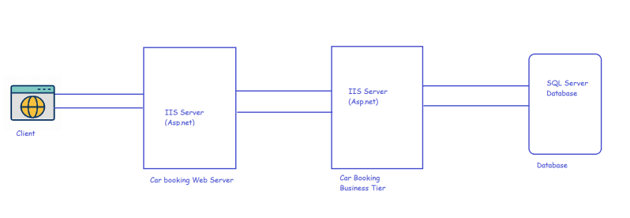
* The current architecture in n-tier application architecture
* Now the Business goals of the Car booking service are
  + Support mobile apps
  + Support Realtime booking of Cars
  + Planning to Serve other developing countries.
* The major components of this application as of now are
  + Web Server
  + App Server
  + Db Server
* As a first step, Architect categorizes the application according to business domains
  + Fleet Management: Here end-user can register their car like OLA/UBER
  + Tracker: Where is my car?
  + Trip Management: Bill calculation
  + Identity & Access Management: Authentication and authorization
* The architecture of the refactored application looks as shown below 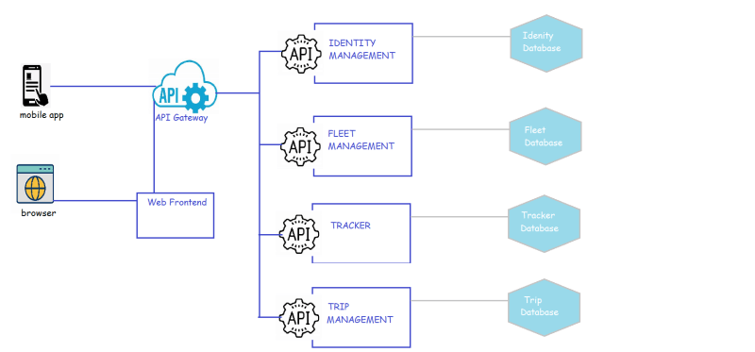
* Now, each application is owned by a different team. Each microservice will have its own database.
* Each microservice will have automated CI/CD pipeline. 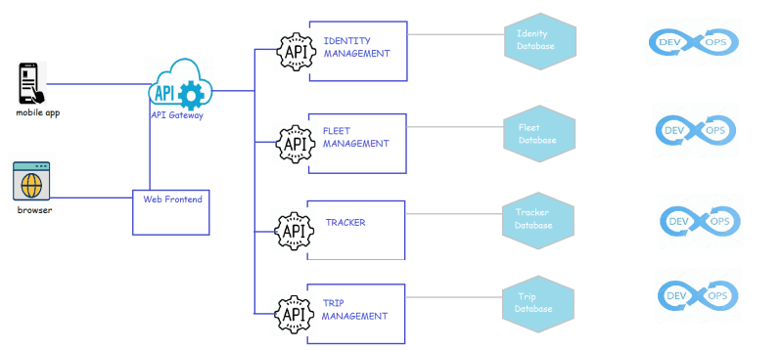
* To realize this application
  + Each microservice has a docker image
  + This docker image is used to create a Kubernetes deployment 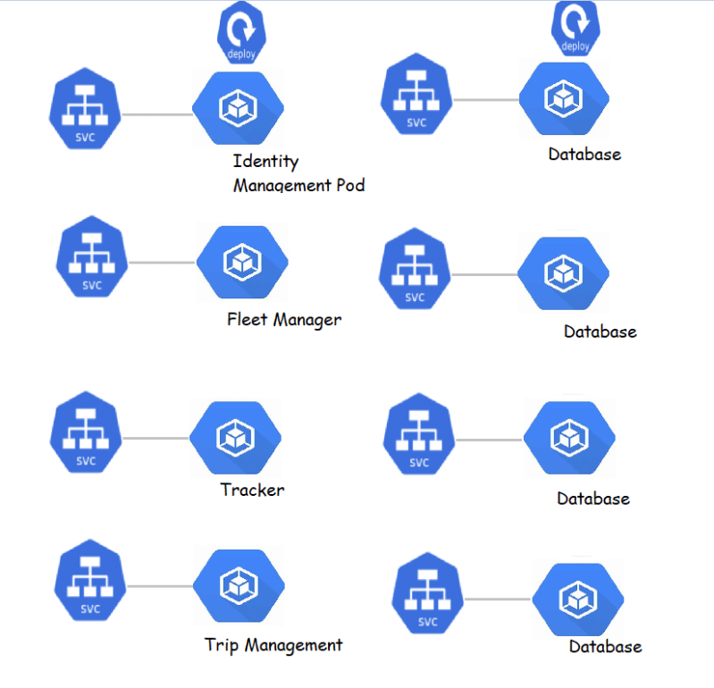
* To understand communication b/w microservices, we need to understand
  + How container in a Pod gets a network?
  + How can two containers in the same pod communicate with each other?
  + How Pod to Pod networking works?
  + How service to Pod networking works?
* How virtual networking works?
* What is bridge?
* Container Networking?
* Pod Networking?

Note: Strangler Pattern is used to switch to microservices from monoliths 